

Name : Tan Yng Chun

Login ID : tanyngchun@oasis-portal.com

Course title : Executive Diploma in Culinary Arts & Hospitality Management

Subject Code : CA02 Culinary Fundamental

Submitted date: 03th August 2017

**Table of Contents**

|  |  |  |
| --- | --- | --- |
| **No** | **Details** | **Page** |
| 1 | Executive Summary | P2-P3 |
| 2 | Introduction | P4 |
| 3 | Assignment Question | P5-24 |
|  | Part 1 | P5 |
|  | Part 2 | P6-P7 |
|  | Part 3 | P8-P16 |
|  | Part 4 | P17-P21 |
| 4 | Conclusion | P22 |
| 5 | References | P23-P24 |
|  | Appendix | - |

**Executive Summary**

**For Question 1,**

In a brief but comprehensive response, define culinary and its connection with hospitality industry.

We are always needed to keep our passion for devoted ourselves to the culinary. Why? To the hospitality industry, culinary plays an important role for make effort in a perfectly food service. To food industry, culinary art is represented and perform why food industry so glamorously to someone, due to it is fantastically property in different type of dishes in our country. Like Malay, Chinese, Indian, Western, and Pastry that have obviously characteristics for every race.

**For Question 2,**

List and connect the culinary learning objectives with its importance.

Culinary art is connecting with our life. It brings us about the splendid of life and leads us to a better life. It let us know about why so important of culinary art to a food industry and what is connecting closely with hospitality industry.

**For Question 3,**

Define what food safety is and connect it with an example and the food borne illness that will be caused without proper handling.

Food safety is about the food hygiene, right temperature for cooking and storing food, and keeps clean- that is the first rule for food safety. The first thing I learned from the question is why important to keep clean and how to keep clean, it taught me about what will happened if the food handler is contaminated, it will seriously cause someone get infected because of the contaminated food handler. For ourselves and the other ones, we must keep clean and constantly practices it as a habit whenever where you are.

**For Question 4,**

List the parts on lamb and connect it with a suitable cooking style.

Learn part on lamb and choose a suitable cooking style for it is an important skill to a cook. Different parts with different cooking styles are an interesting thing to a cook, which is the alluring of culinary skill to us.

**Introduction**

Simply said, the Culinary Fundamental is a basic cooking technique. It teaches us about the basic knife skills, food safety and nutrition, how to use the kitchen tools and equipments, includes the principles of cooking at kitchen, the principles of preparing the stocks, sauces, and soups.

Once we get the key of culinary, we will know what we should do, how can we do when we face problem in the kitchen. Culinary train us on how to solve the problem with a professional way and start it from the fundamental.

**Assignment Questions**

**Question 1**

In a brief but comprehensive response, define culinary and its connection with hospitality industry.

The word “culina/culinae” mean the kitchen. But the word “culinary”means someone or something that are related to the cooking. The culinary art mean the preparing, making and production of food, for the objective of consumption. Usually, we call the one who are responsible for doing the things “chef”. A chef normally is working at a restaurant or hotel, which means in the service industry, a chef is important because he is a major people to do contribute to the hospitality industry. Why it is connect to the hospitality industry? The reason is the chef is a part of hospitality industry, as a center, the one who at this position should be trained, skilled and professional. The chef may be study at the institute or an experiment cook. For the culinary fundamental, we constantly learn it patiently for obtain a better life and do it as a lifelong career. The career is not a reward career, someone do in this is always full of the spirit of self-sacrifice, they are always do not own the time by themselves, the long working time is a reason and it cause many people to give up. But once when you love for this, you are hard to relinquish, because the career is always attractive to the people.

**Question 2**

List and connect the culinary learning objectives with its importance.

The culinary is an important skill to people’s life. Probably we should be said, the food is important to peoples. But not just for the gourmet’s luck, a good-looking, good taste, good texture food is a form of culinary art.

**2.0.1.1 Receive, store & check goods**

* Receive and check goods delivered
* Store food by arrival order, at the right place and temperature

**2.0.1.2 Organize yourself for better time management & multi-tasking performance**

* Learn how to approach a recipe
* Determine ingredients and material requirements
* Organize your work station
* Identify proper food-handling procedures and mise-en-place techniques

**2.0.1.3 Acquire preliminary food preparation techniques & cutting methods**

* Vegetables, fruits and cereals
* Herbs, spices and condiments
* Fish, shellfish & crustaceans
* Poultry and meat

**2.0.1.4 Learn classic bases & sauces**

* Prepare Ducasse’s style stock, fumet, broth and jus
* Acquire culinary bases: vegetable purees, soups, marinades, condiments
* Prepare classic French sauces
* Learn traditional Mediterranean and contemporary recipes

**2.0.1.5 Learn fundamental cooking methods**

* Sautéing & roasting
* Poaching & steaming
* Braising & confit
* Grilling & frying

**2.0.1.6 Learn French pastry arts fundamental techniques**

* Use professional equipment and tools
* Prepare essential dough and creams
* Bake, decorate and plate desserts
* Make classic French pastries

**2.0.1.7 Plate and serve final food preparations**

* Taste, analyze and adjust culinary production
* Select proper serving equipment
* Plate dishes according to chef instructions
* Apply modern presentation technique

The culinary art was found at the end of Renaissance period. In Paris of 18th century in 1765, we can find out for three theories about who the first one to opened the first modern restaurant in the world. The first theory is about a French restaurateur who called by Monsieur Boulanger. We actually cannot find too more things about Monsieur Boulanger, for Monsieur Boulanger, what we knew was he is a soup maker; the main course of the restaurant is soup. The soup is a kind of dishes that have restores characterizes, in the purpose of healthy. It plainly tell us about the origin meaning of the word restaurant which derives from French, restaurer which means “to restore”, it also means the one who provide food to someone in need. Changes by the time, restaurer become the restaurant, which mean the place that provides food to people. About the second theory, Mr. Mathurin Roze de Chantoiseau, who was a son of a rich landowner and merchant in Chantoiseau. He moved to Paris in 1760s and started his first establishment in 1766. He not like the other cook, because he done all of the food in a healthier way and served in a maison de santé in Rue Saint-Honore, it mean the nursing house. Antoine Beauviliers, the third theory for who started the first modern restaurant in 18th century, Mr. Antoine Beauviliers is the first who really open a grand restaurant named La Grande Taverne de Loudres in the 1782, because he be the first one had the four elementary for dining, an elegant dining room, a trained waiter, a wine cellar, and the most important one, an excellence cook.

For Food and Beverages, a support sector in hospitality industry, culinary art is constantly be the center of Food and Beverages, a food service always lay emphasis on a chef is because a professional chef is the main force to hospitality industry. A chef that are trained and skilled, he will know how to do the kitchen management, and persistently on blaze new trail to the recipes and menu, a goodly menu can attractive the customers and make contribution to the restaurant. A professionally chef that can fulfill the meet of customer is permanently requirement by the hospitality industry.

**Question 3**

Define what food safety is and connect it with an example and the food borne illness that will be caused without proper handling.

Every country has a different food safety standard. But the same knowledge to the country is also the food safety. Food safety is when we do the food handle, preparation, and storage, we must keep our hand is clean by always washed before and after do the food handle, always separated the raw food and the cooked food for prevent the cross-contamination, cooked the food at an accurate temperature by measured with a food thermometer, food inside refrigerator or freezer. Food safety is a scientifically on many disciplines about food, it should be popularize for environment.

In 2017, World Health Organization already gives us the “five steps to safer food and gets a better life”.

1. Keep Clean

Whatever we learn about, everything should be start from the basic. No matter what we do, the first thing we learn is how to keep the clean of food and Mise-en-place.

As a habit, before handle food, we always wash and dry our hand thoroughly, wash with soap at least 20 seconds and dry with paper towel, never wipe at clothes because it can cause contaminate too and personal hygiene is very important, when we handling the food, prepared a compost bin for throw the rubbish into it so the Mise-en-place can look neatly, prepare a towel under knife and always use it by clean the surface of cutting board and around.

2. Separate the raw and cooked

For prevent cross-contamination, we always keep the cooked food above the raw meat, poultry, and seafood which will drop juices into the cooked food. If the food is cooked and become perishable, we should consume it as soon as possible. The contaminated food is always being the cause of food-borne illness.

3. Cook thoroughly

Cook the food to the right temperature, this not just for prevent the bacteria to grow but it is crucially related to health issues of humans by through the consumption of food.

Temperature Danger Zone: 41º – 140ºF (5º – 60ºC)

Actually based on record, although the food arrive temperature danger zone, but if we can use it in 4 hours, the toxin will not produce, in detail, half-cooked food under 2 hours we still can put inside refrigerator which is under 41ºF, after 2 hours, we should use it immediately or the bacteria will start grow.

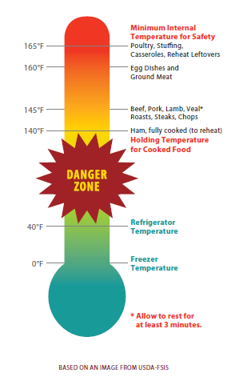

**Figure 0.1 Temperature Danger Zone**

4. Keep food at safe temperature

This is a thing we called it TCS, a basically knowledge for food hygiene, food that need Time and Temperature Control for Safety. It talks about the frozen food need maintain at 0ºF or below; refrigerated food should keep at 41ºF or less, for the hot food should be above 140ºF and dry storage food between 50ºF to 70ºF.

For pass the problem of Temperature Danger Zone, we should do cooling food faster, because it need from 140°F to 70°F within two hours, or from 70°F to 41°F within 2 hours, if first step or 2 steps cannot done in 2 hours, food should be throw or choose reheat and do cooling again, the processing of all cannot longer than 6 hours.

The methods we use for cooling the food:

1. Ice-water bath

2. Ice paddle

3. Blast or tumble chiller

4. Use ice or cold water as an ingredient (like soup or stew.etc)

5. Use safe water and raw materials

Safe water such as pasteurized milk, it is free from microorganisms and harmful substances, but in law, the word “contaminate” is very broadly mean in different area, generally say is physically, chemically, biologically and radiologically matters in the water and people get sick because of drink the water.

Different with safe water, raw material is unprocessed food, there are some we must washing thoroughly it before eating, there are some examples and explain for raw materials.

1. Eggs

In a western restaurant, egg is usually prepared for breakfast, some simply dishes like Egg Benedict it is dressing by Hollandaise sauce which is made by egg, butter and olive oil, eggs is also usually use in mayonnaise, custard, and baking foods.

2. Milk products

Milk is a whitish liquid which is contains protein, lactose, fats, water and various minerals and vitamins that be produced by mammary glands of mature female mammal.

-Cheese, cheese is produced by 2 major component of milk, milk protein (casein) and milk fat. It is source of milk protein, calcium & phosphorus, it actually benefit to human’s bone and dental, like yogurt, it also good to heart health in consumption by appropriately. We got several types of cheese.

1. soft cheese (camembert, feta, celtic)
2. semi soft cheese (gouda, muenster, port soft, etc)
3. hard cheese (aged manchego, mimolette, tuscano, pelorina, etc)
4. semi hard cheese (cheddar, edam, emmental, cantal, etc)
5. blue cheese (roquefort, stilton, etc)
6. fresh cheese (cottage, mozzarella, etc)
7. processed cheese

-Yogurt, it is source of calcium and vitamins of B2. B3, B12. Microorganism can ferment the non-dairy milk into yogurt; there is coconut milk, soy milk and almond milk. Yogurt is good to digestive system because based on the research, 1 cup of low-fat yogurt less than 3 gram of fat.

3. Salt

Salt can use as preserved for the bacon, fish, and ham, enhance the flavor of dishes. Common salt we use every day is sodium chloride, ratio of water between salt is important to our metabolic rate.

1. Table salt – The commonly salt we see by every day,
2. Sea salt – Sea salt contain a small amount of iodine which can help to prevent hypothyroidism. It got fine and coarse 2 types that can let people choose.
3. Himalayan Pink salt – It comes from the Himalaya mountain, it help in balance the blood sugar problem, reducing muscle cramp, and pH cell in your body.
4. Grey salt – Grey salt is normally called by Celtic Sea Salt. It color from where it harvest- the clay, natural clay, it maintain its moistness for create mineral-rich crystal. .
5. Fleur de sel salt – It as famous as “Flower of the Salt”, like grey salt, it can hand-harvested the coastline of French, but it no produce as much as grey salt, because based on my research, every [40 kilograms of grey salt produced](http://www.vegkitchen.com/tips/a-guide-to-salt-varieties/), only 1 1/2 kilograms of delicate fleur de sel is harvested.
6. Black salt – The salt from Hawaii, it is healthily for remove the impurities from body and good for digestion, black color come from the activated charcoal.
7. Red salt – Like Black salt, it originally from Hawaii, it fine out from the clay of volcanic, it rich in iron and mineral, good for balance the diet of body.
8. Persian Blue salt – The salt is rich in mineral and slightly sweet, it no higher health value to humans.
9. Smoked salt – It smoked at low temperature of coal. It higher in mineral and lower in sodium.

4. Sugar

Sugar is fermentation by yeast. Like to salt, it also can use for preservation purpose, we know the vegetables and fruits had a lot or some sugar, it help to balance the sour, spicy and bitter, for it viscosity, it is texture, body, and palatability. For baking, the more sugar it had, the browner color.

5. Fats and Oils

Examples of animal fat:

-Lard, pork’s fat,

-Suet, fat around kidney of animals

-Dripping, beef’s fat.

Examples of oil are:

-Butter, it is produced by churning fresh cream or milk. Usually butter that we use is made from cow’s milk. We actually can find the butter in supermarket which is labeled “sweet cream butter”, that mean the cream used for make the butter is pasteurized, the prohibited to sell at market is the raw butter which are make by raw milk.

-Margarine, margarine is made by vegetable oil, water, and salt, emulsified with lecithin and sometime includes milk at the times. It firstly made by animal fat at 1800s, but now it is under law and it must have content of 80 percent fat like butter. But depend on the level of water and vegetable oil, the higher fat content, the less of water level.

-Oil, which are obtained from sunflower seed, palm, groundnut and soya bean. At room temperature, oil in liquid state is kind of fat, no like butter and margarine is a kind of solid fat, because both of them is solid state under room temperature, oil is fat in liquid state that are known by people.

6. Raising agents

Raising agent usually use in dessert like doughnut and profiterole, it make the surface area of dough bigger by gas bubbles puffing up when inside the oven and lighter the weight.

-Baking powder, it is normally use for café-making, it made from alkali, bicarbonate of soda, and an acid, cream of tartar, plus filler like corn flour or rice flour which can absorbs moisture. When liquid add to the baking powder, it will active and formed the bubble, we need inside the cake into oven quickly. A small amount of baking powder mix with plain flour can make self-raising flour.

-Yeast, in people’s knowledge, yeast is very helpful for bread in baking, wine fermentation, and brewer for beer’s fermentation. S.Cerevisia is a kind of yeast commonly knows by people because it famous as a top fermenting yeasts. It is a source of protein, B vitamin, and minerals. Yeast can easily convert to sugar and alcohol; it can be finding above the skin of grapes, grape juices ferment into wine by yeast.

7. Herbs and Spices

Spice is made from fruits, seeds, roots, flowers or the bark of different trees or shrubs.

Dry Herbs and Spices:

* Rosemary
* Cayenne pepper
* Saffron
* Coriander seed
* Turmeric
* Loomi
* Mace
* Paprika
* Sumac
* Sage
* Thyme
* Turmeric

**3.1.1.0 Hazard Contamination**

Basically, we know the cross-contamination of food can cause the food poison to humans, but we never know the food poison just a form of food-borne. The food-borne can be causes by bacteria, viruses, parasites, and natural toxins.

**3.1.1.1**

**The bacteria pathogens are:**

* Campylobacter jejuni

Campylobacter is mean the “twisted bacteria”, it commonly been find at the cattle or man in the United Stated and Europe. It makes the muscle weakness of permanent, the initially characteristics is abdominal pain, diarrhea, fever and then malaise. The bacteria aggregate in the small and large intestines, the peripheral nervous system wrongly attacked by the immune system, and finally cause the Guillian-Barr[é syndrome](https://en.wikipedia.org/wiki/Guillain%E2%80%93Barr%C3%A9_syndrome).

* Clostridium perfringens

Clostridium perfringens is found out in the intestinal tract of humans and animals, insect, soil and vetebrates. It appearance as physically, it is blisters, tachycardia, swelling, and jaundice. Clostridium perfringens usually will not infection to another one, it d maybe have an abdominal pain but does not have fever or vomit. If it not get the properly therapy, it first will start from decrease blood pressure, kidney failure, coma and final dead. The things of a form of tissue death it called gas gangrene.

* Salmonella

Normally, humans get infection of salmonella bacteria from raw meat, raw egg, milk, or the juices from the raw meat drop into the uncooked food like fruits and vegetables, and human eat it with hand unwashed after used the bathroom. It is a disease only need 12-72 hours or 2-7 days for morbidity. Its symptoms are diarrhea, fever, abdominal cramp, and vomit. Salmonella occur in a children or an adult, to a children it may take time for several months for treatment until the bowel movement back to normal, it is not a disease which is easily cure to an adult, because it can develop to reactive arthritis if the patient ignore the signature from the body, arthritis perhaps lead to chronically arthritis.

* Escherichia coli O157 :H7

Like the other intestines track diseases, Escherichia coli have the symptoms of diarrhea, abdominal pain, fever, nausea, but it is seriously can leads to the small amount and bloody urine, bloody diarrhea from watery diarrhea, anemia, dehydration, or even kidney failure which can cause the death of human. It usually needs 3-4 days for expose in patient, but for some especially example it maybe need 1 day to occur. What we can do for prevent and treatment is not swallow the water when swimming in a manual pool and do not take the unpasteurized milk, cheese, or cream as an edible food, when we buy the product you make sure they are labeled the word “pasteurized”. If we are diarrhea, we should not take the antidiarrheal that are labeled Loperamide in their ingredients such as Maalox, and Imodium, and the other that are contains Salicylate, a salt of salicylic acid that are commonly used in drugs, it can cause the increase bleeding of intestines and deterioration of liver function, such as the Aspirin and Ibuprofen, the other we should avoid to take is Difenoxin and Diphenoxylate with atropine, such as the Motofen and Lomotil.

The other common diseases caused by bacteria are:

* Bacillus cereus
* Escherichia coli, enteroinvasive (EIEC), enteropathogenic (EPEC), enterotoxigenic (ETEC), enteroaggregative (EAEC or EAgEC)
* Listeria monocytogenes
* Shigella
* Streptococcus
* Vibrio cholera

**3.1.1.2**

**The virus’s pathogens are:**

* Enterovirus

Enterovirus is urgency for remedy because it will cause the poliovirus and nonpolio-virus. It comes from a small RNA virus. Non-polio enterovirus is perceived by human and it was called by EV-D68 and EV-D71. EV-D68 and EV-D71 is a kind of paralytic poliomyelitis, it about the neurological of human and it is the major cause of hand-foot –mouth syndrome (HFMD), it had symptoms high-fever, anepithymia, blister, and sore of throat (hoarsely voice). To polio enterovirus, it from a big family of viruses named Picornaviridae, member such as Coxsackievirus (A and B), unclassified enteroviruses, 33 echoviruses, and rhinoviruses. Most of them re are mostly infect to infants, children, and teenagers.

* Hepatitis A
* Hepatitis F
* The word “Hepatitis” is denotes the viral inflammation of liver. It is a kind of virus that can cause the unexpected hepatic failure to the only reservoir, human. Hepatitis A (HAV) get infected from contaminated food, drink, and blood with stool, for instance, sexual contact by oral or anal. Not like Hepatitis B and C, Hepatitis A no easily cause to long-term problem, it about the poor sanitary condition and can treatment within one month. We should always wash our hand and dry it with sterilize paper after bathroom; eat the food and drink that are heated to 185°F. For hepatitis viruses, the best prevent way is vaccines. For children that are older than one year, government will suggest the parents for let their children to accept the vaccines, protection will start within 2 to 4 weeks, for a chronically protection, children will accept the second vaccine after 6 to 18 months, the vaccines can constant at least 20 years. Hepatitis F (HFV) is isolated from rare blood sample, and we cannot find out any more about it, we even cannot prove HFV is existed or not.
* Norovirus
* Rotavirus

Norovirus and rotavirus is a kind of disease that commonly found in causes of gastroenteritis. Quite simply put, the both virus are incubate during the cooler stages, infected through eaten the food that are not clean enough and handle by a dirty hand. The difference between norovirus and rotavirus are norovirus toward to all ages but rotavirus usually break out in children, which means the rotavirus can treat by vaccine, but the vaccines no use to norovirus. For clearly characteristic for the both viruses is, the norovirus can seem as without fever, or the fever is around 37degrees C, the patient repeat vomiting for 4 times a day, about the rotavirus is through the diarrhea about 7 times in one day and fever above 38 degrees C.

**3.1.1.3**

**Parasites Pathogens are:**

* [**Platyhelminthes**](https://en.wikipedia.org/wiki/Platyhelminthes)**:**
* [Diphyllobothrium](https://en.wikipedia.org/wiki/Diphyllobothrium) sp.
* Nanophyetus sp.
* [Taenia saginata](https://en.wikipedia.org/wiki/Taenia_saginata)
* [Taenia solium](https://en.wikipedia.org/wiki/Taenia_solium)
* [Fasciola hepatica](https://en.wikipedia.org/wiki/Fasciola_hepatica)
* [Tapeworm](https://en.wikipedia.org/wiki/Tapeworm) and [Flatworm](https://en.wikipedia.org/wiki/Flatworm)
* [**Nematode**](https://en.wikipedia.org/wiki/Nematode)**:**
* [Anisakis](https://en.wikipedia.org/wiki/Anisakis) sp.
* [Ascaris lumbricoides](https://en.wikipedia.org/wiki/Ascaris_lumbricoides)
* [Eustrongylides](https://en.wikipedia.org/wiki/Eustrongylides) sp.
* [Trichinella spiralis](https://en.wikipedia.org/wiki/Trichinosis)
* [Trichuris trichiura](https://en.wikipedia.org/wiki/Trichuris_trichiura)
* [**Protozoa**](https://en.wikipedia.org/wiki/Protozoa)**:**
* [Acanthamoeba](https://en.wikipedia.org/wiki/Acanthamoeba) and other free-living [amoebae](https://en.wikipedia.org/wiki/Amoeba)
* [Cryptosporidium parvum](https://en.wikipedia.org/wiki/Cryptosporidiosis)
* [Cyclospora cayetanensis](https://en.wikipedia.org/wiki/Cyclospora_cayetanensis)
* [Entamoeba histolytica](https://en.wikipedia.org/wiki/Entamoeba_histolytica)
* [Giardia lamblia](https://en.wikipedia.org/wiki/Giardia_lamblia)

**3.1.1.4**

**Natural Toxins are:**

* [Alkaloids](https://en.wikipedia.org/wiki/Alkaloid)
* [Ciguatera poisoning](https://en.wikipedia.org/wiki/Ciguatera_poisoning)
* [Grayanotoxin](https://en.wikipedia.org/wiki/Grayanotoxin) ([honey](https://en.wikipedia.org/wiki/Honey) intoxication)
* [Mushroom](https://en.wikipedia.org/wiki/Mushroom_poisoning) toxins
* [Phytohaemagglutinin](https://en.wikipedia.org/wiki/Phytohaemagglutinin) (red [kidney bean](https://en.wikipedia.org/wiki/Kidney_bean) poisoning; destroyed by boiling)
* [Pyrrolizidine alkaloids](https://en.wikipedia.org/wiki/Pyrrolizidine_alkaloid)
* Shellfish toxin, including [paralytic shellfish poisoning](https://en.wikipedia.org/wiki/Paralytic_shellfish_poisoning), diarrhetic shellfish poisoning, neurotoxic shellfish poisoning, [amnesic shellfish poisoning](https://en.wikipedia.org/wiki/Domoic_acid) and [ciguatera](https://en.wikipedia.org/wiki/Ciguatera) fish poisoning
* [Scombrotoxin](https://en.wikipedia.org/wiki/Scombrotoxin)
* [Tetrodotoxin](https://en.wikipedia.org/wiki/Tetrodotoxin) ([fugu fish](https://en.wikipedia.org/wiki/Fugu_fish) poisoning)

Some plants contain substances which are toxic in large doses, but have therapeutic properties in appropriate dosages.

* [Foxglove](https://en.wikipedia.org/wiki/Foxglove) contains [cardiac glycosides](https://en.wikipedia.org/wiki/Cardiac_glycosides).
* Poisonous hemlock ([conium](https://en.wikipedia.org/wiki/Conium)) has medicinal uses.

**Question 4,**

List the parts on lamb and connect it with a suitable cooking style.

Lamb is under one year old we can call it “lamb”, above we called it “mutton”.

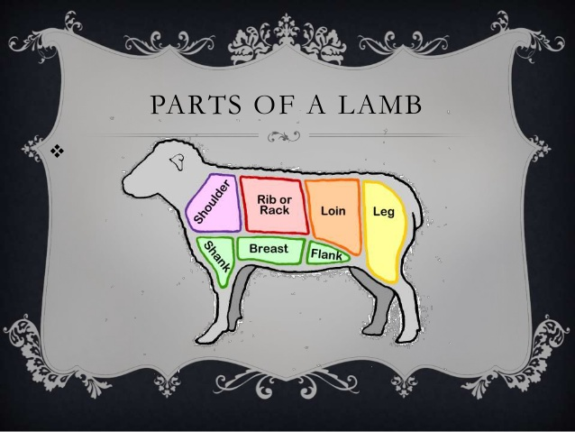

**Figure 2.0 Parts of Lamb**

**4.1.1.1**

There are 5 basic cuts of lamb it is: Shoulder, Breast/Fore shank, Rib, Loin/Flank, and Leg.

**4.1.1.2 Shoulder**

Shoulder can divide into 3 subprimals, neck, blade and arm. The parts of lamb require longer cooking time and it used to cooking methods such as grilling, braising, stewing, and roasting. The neck can cut into 3 parts that is neck slices, stew meat, and ground lamb. It cooked by moist heat because it is small and tough. The blade can be 3 parts too, that is blade roast, blade chop, and saratoga roll. Blade roast is cut from the shoulder blade section of shoulder primal, blade chop is vary tenderness in different degree, because it cut from the back side of shoulder. A Saratoga roll is boneless and it rolled from the centre of shoulder between blades. It contains a rib eye muscle that called chuck eye and the eye made it become tenderness. The arm also got arm chop and arm roast. An arm chop cut from the upper section of arm is less tender than blade chop. An arm roast is cut from the upper arm section of shoulder.

**4.1.1.3 Breast/Foreshank**

Lamb shanks come in both fore shanks and hind shanks. It referred as lamb trotter which means the feet of sheep. Shanks are easily pulled apart when in slowly braising or stewing; because it is full of connective tissues that mean it need cook with longer and slowly, the juices strands will come out and make it into savory broth.

**4.1.1.4 Rib/Rack**

Rib of lamb or a full rack of lamb contain 8 ribs, we normally divided into sparerib, riblet or Denver rib, Spareribs is usually cut from the end of the breast; in professionally, we should call it lamb riblet which is trimmed in fat and use to broiled, barbequed, and braised. Sparerib can separate into riblets, a boneless cut of meat. A Denver rib is includes 7 or 8 ribs same from the breast of lamb, compare with braise or grill, it most suitable by marinate. If the meat and fat from the rib bone had been cutting off and exposed the bones, which is a Frenched rack. Generally, 3 inches of bone connect with main muscles is exposed and 2 inches of meat is left.

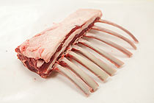

**Figure 3.0 a Frenched rack**

A crown roast of lamb is tie up 2 or 3 single racks of lamb by kitchen twine and circle it into a crown shape, a roast of lamb should be no more than 325°F, the first step is preheat the oven to 375°F, once we pressed all over the lamb with olive oil, kosher salt, ground black pepper, ground coriander, chopped fresh thyme, and minced garlic, we put it inside the oven for 30 to 35 minutes, wait for the meat internal and outside temperature reached 130°F or 115°F, take out from the oven and cover with aluminum foil and let it rest for 20 minutes. After 20 minutes, we take off the twine and add rosemary, asparagus, sherry vinegar, and hollandaise sauce to its flavor and use a Bundt pan to form it.

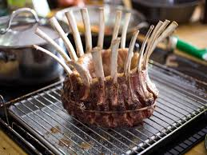

**Figure 3.1 a crown roast of lamb**

**4.1.1.5 Loin/Flank**

Loins chops can be grill, broil, sauteed and panfry, it can marinate with 4 to 6 hours, it known by people as T-shape bone, and it cut from the leg, lamb loin suitable for cooked to rare and medium-rare, because the meat is very tender and leaner the rib chop but lack of the rib bone.

**4.1.1.6 Leg**

A whole boneless leg of lamb normally weight between 7 to 8 pounds. In market, we can find the leg which is bone or boneless, the boneless one we called BRT leg. Lamb leg we usually cooking by roasted, but it also can be boned and butterflying, or marinated for several hours before grilling. For shank-on leg, we called “American leg” or “shank-on leg” to a leg still left the lower part on it. Basically, we find a lamb leg without lower part in the market, like picture at below.

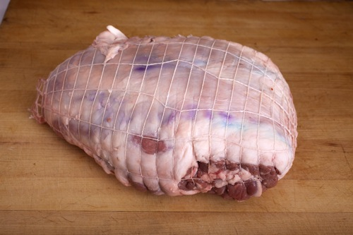

**Figure 3.2 Lamb leg without lower part**

And about the “shank-on leg”, it should be like this:

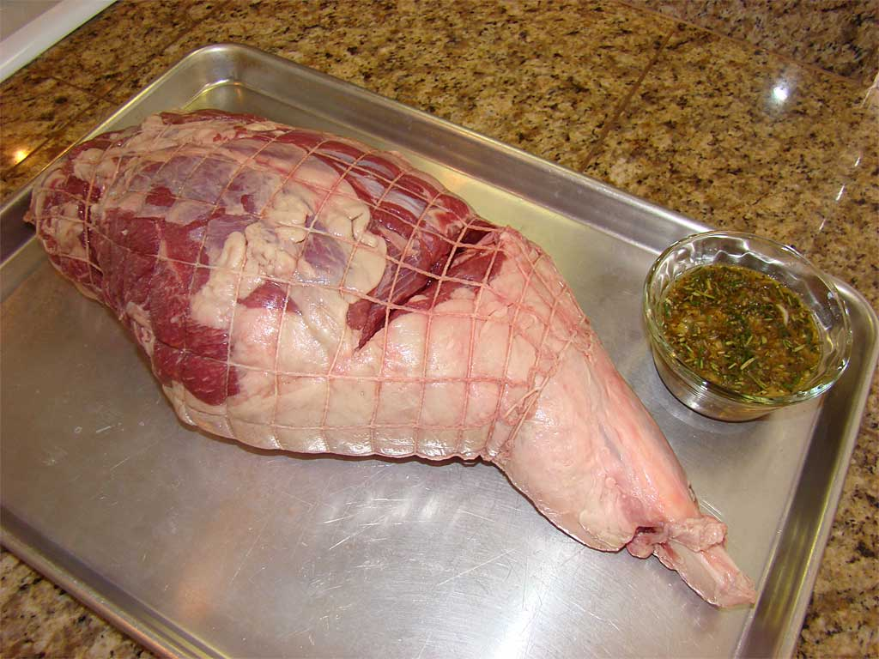

**Figure 3.3 American leg/Shank-on legs**

A lamb leg is naturally tender so although we can marinate it but cannot over 2 to 3 hours or the meat become tougher.

**Roasting Temperature:** 325°F

* **Rare:**125°F (about 15 minutes per pound)
* **Medium-Rare:**130°F to 135°F (about 20 minutes per pound)
* **Medium:**135°F to 140°F (about 25 minutes per pound)
* **Well-Done:** 155°F to 165°F (about 30 minutes per pound)

**Conclusion**

Fundamentals of culinary should be learning by every chef, it let a chef grow and got a basic of steadfast, basic is very important for cause directly or indirectly effect on our life. It training us for keeps continually growth from experience of failure. The work is so hard and already so many people raised white flag. It bring to us a stronger body and mental. Culinary fundamental just first step that we got for throw ourselves to this career, never think someone can keep working as a chef if him/she is never learned about the fundamentals.

**References**

Unknown. (2015, Mar 24th). *USDA*. Retrieved Jul 19th, 2017,

https://www.usda.gov/: https://www.fsis.usda.gov/wps/portal/fsis/topics/food-safety-education/get-answers/food-safety-fact-sheets/safe-food-handling/basics-for-handling-food-safely/ct_index

Brandt, K. (2016). *University of Minesota Extension*. Retrieved July 22th, 2017,

http://www.extension.umn.edu/: https://www.extension.umn.edu/food/food-safety/food-service-industry/prep-storage/what-is-the-risk-cooling-hot-food/

Service, G. F. (2016, Mar 04th). *Gordon Food Service*. Retrieved July 22th, 2017,

https://www.gfs.com/: <https://www.gfs.com/en/ideas/tips-for-time-and-temperature-control-tcs-foods>

Shirke, G. (2016, Jan 6th). *Linked In*. Retrieved Jul 23th, 2017,

<https://www.linkedin.com/>: <https://www.linkedin.com/pulse/raw-materials-used-kitchen-gajanan-shirke-mih-author-trainer>

Unknown. (2016, Oct 19th). *Choosemyplate*. Retrieved Jul 23th, 2017,

https://www.choosemyplate.gov/: <https://www.choosemyplate.gov/oils-fats>

Association, T. S. (2015, May 16). *theSugarassociation*. Retrieved Jul 24, 2017,

https://www.sugar.org: https://www.sugar.org/why-is-sugar-added-to-our-foods/

Bhattacharjee, S. (2013, Oct 22th). *slideshare*. Retrieved Jul 24th, 2017,

https://www.slideshare.net/: https://www.slideshare.net/saugatbhatt/fermentated-milk-products?next_slideshow=1

Elam. (2012, Sep 20). *slideshare*. Retrieved Jul 24, 2017,

https://www.slideshare.net: https://www.slideshare.net/jovenpakistani/importance-of-yeast

Foster, K. (2015, Sep 08th). *thekitchn*. Retrieved Jul 24, 2017,

www.thekitchn.co: http://www.thekitchn.com/whats-the-difference-between-butter-and-margarine-223410

G.Hinnebusch, A. (2011, Nov 11th). *GENETICS*. Retrieved Jul 24th, 2017,

http://www.genetics.org/: http://www.genetics.org/content/189/3/683

Moncel, B. (2017, May 26th). *thespruce*. Retrieved Jul 24, 2017,

https://www.thespruce.com/: https://www.thespruce.com/what-is-yeast-1328649

Montagné, P. (2001). Larousse Gastronomique: The World's Greatest Culinary Encyclopedia. In P. Montagné, & J. H. Lang (Ed.), *Larousse Gastronomique: The World's Greatest Culinary Encyclopedia* (P. Montagné, Trans., 3rd English Edition ed., p. 1350). New York, United States of America: Clarkson Potter.

Brown, A. (2008). *foodnetwork*. Retrieved Jul 25th, 2017,

http://www.foodnetwork.com: http://www.foodnetwork.com/recipes/alton-brown/crown-roast-of-lamb-recipe-2082917

Loosli, L. (2017, July 19th). *food storage moms*. Retrieved July 25, 2017,

http://www.foodstoragemoms.com/: http://www.foodstoragemoms.com/category/food-storage/

Vivek, A. (2016, Oct 6th). *slideshare*. Retrieved Jul 25th, 2017,

https://www.slideshare.net: https://www.slideshare.net/AbhinavVivek1/fermented-milkproducts?qid=51a9fe91-711f-4915-a50b-b15d0b954ab4&v=&b=&from_search=5

Durand, F. (2017, Apr 11th). *thekitchn*. Retrieved Jul 26th, 2017,

http://www.thekitchn.com: http://www.thekitchn.com/how-to-roast-a-leg-of-lamb-cooking-lessons-from-the-kitchn-202391

Alfaro, D. (2016, Nov 29th). *thespruce*. Retrieved Jul 26th, 2017,

https://www.thespruce.com/. https://www.thespruce.com/beef-chuck-steaks-and-roasts-995239

**THE END**